**Day 4 Assignment1: Difference between scrum vs Kanban**

**Overview:**

In the world of Agile project management, there are two popular methodologies, Kanban and Scrum, have gained significant attention. Each offers unique approaches to organizing and executing tasks, serving different project requirements. To make informed decisions and adopt the most suitable method for their project it is important to understand the key differences between Kanban and Scrum.

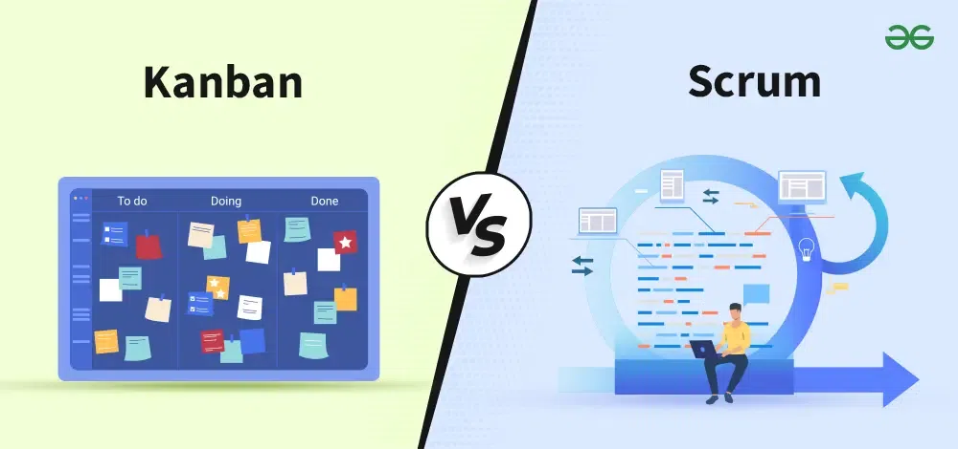

**Kanban:**

Kanban is all about visualizing your work, limiting work in progress, and maximizing efficiency (or flow). Kanban teams focus on reducing the time a project takes from start to finish. They do this by using a kanban board and continuously improving their flow of work.

**Kanban roles:**

The whole team owns the kanban board. Some teams enlist an agile coach but, unlike scrum, there is no single “kanban master” who keeps everything running smoothly. It’s the collective responsibility of the entire team to collaborate on and deliver the tasks on the board.

**Scrum:**

Scrum teams commit to completing an increment of work, which is potentially shippable, through set intervals called sprints. Their goal is to create learning loops to quickly gather and integrate customer feedback. Scrum teams adopt specific roles, create special artifacts, and hold regular ceremonies to keep things moving forward. Scrum is best defined in the scrum guide.

**Scrum roles:**

Scrum has three clearly defined roles.

* The product owner  advocates for the customer, manages the product backlog, and helps prioritize the work done by the development team.
* The scrum master helps the team stay grounded in the scrum principles.
* The development team chooses the work to be done, delivers increments, and demonstrates collective accountability.

**Difference between scrum and kanban:**

Kanban and Scrum are two different Agile project management methods, and we should choose the right methods depending on our project requirements and team preference. So, these differences will help you make decisions for the adoption of the most suitable approach for your project. Here are the top difference between Kanban and Scrum

**Scrum:**

**1**.It defines the role of each member of the Scrum team.

**2**.It follows the iterative method.

**3**.To solve a problem, it breaks it into small tasks and then processes it further.

**4.**There is no visualization process to perform tasks.

**5.**The process does not get disturbed if a team member leaves in between a sprint.

**Kanban:**

**1**.There is no role assigned to individuals.

**2.**It does not follow the iterative approach.

**3**.It does not break a problem into sub-problems.

**4**.There is a visualization process to perform tasks.

**5**.The flow of work gets disturbed if a team member leaves in between.

**Conclusion:**

Kanban and Scrum are two ways to manage projects, having some differences that you should know. Kanban focuses on continuous flow and adaptability where work done is more smooth and flexible, while Scrum works in a more structured approach. So by learning the above difference, you can make better decisions and make your project more efficient. Each method has its unique capabilities, so choose the right one which suits your project’s needs and team preference.